Lecture: Exploring Nature with Paper + Stitch

Presenter: David Owen Hastings
In this lecture, I talk about my work as a visual artist, and how there are similarities to how I now work as a quilter.

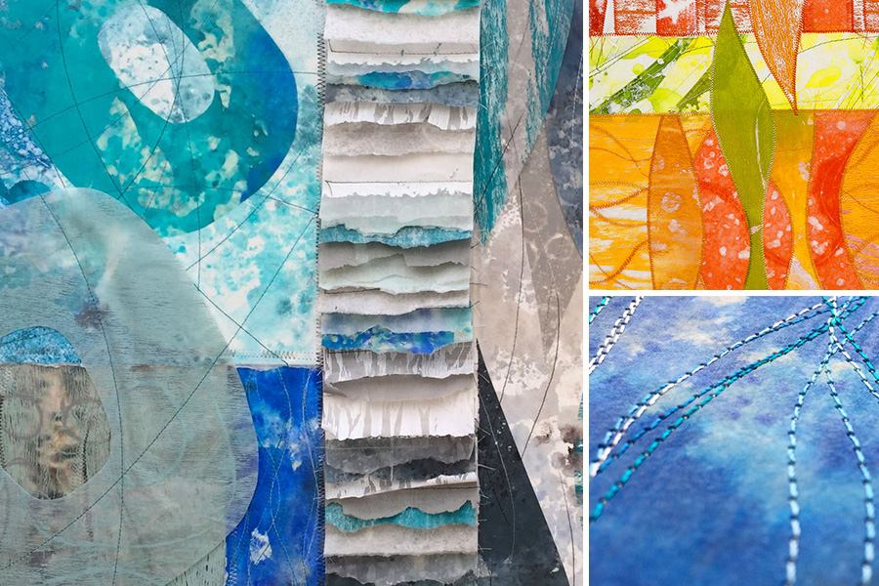

David’s Journey from Stitching Paper, to Stitching Fabric
1 hour + Q&A: This talk starts with a review of David’s stitched paper artwork, which he has been creating and showing in galleries for over 20 years. He will give examples of where his inspiration comes from, and what his creative process is like. His artwork appeals to those who love organic processes and the beauty of nature, color and texture. David combines his monotype-printed paper with stitching on a vintage sewing machine. He will show examples and include details for those interested in creating their own stitched paper artwork.
In recent years, David has become enchanted with modern quilting and was 2020 President of the Seattle Modern Quilt Guild. He will talk about how quilters can find inspiration in the world around us, and how his journey as a maker has taken him from gallery artist into the world of modern quilting.
This lecture ties directly into my online workshop, Stitched Paper Collage.

ZOOM WORKSHOP DETAILS
This live stream lecture is available using Zoom technology (no recording please).

For more about David, please visit www.davidowenhastings.com or follow @davidowenhastings on Instagram.

